FOR CFAS OFFICE USE

Project no. ............................
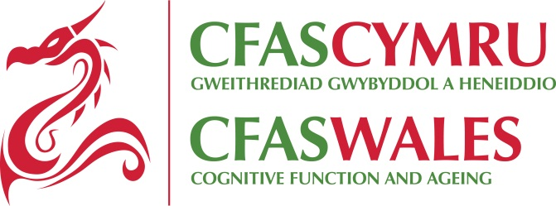

UNDERTAKING FOR USERS OF CFAS WALES DATA

All use of the CFAS Wales data should be in agreement with the conditions as specified below:

- Purpose: To use the materials only for the purposes of non-commercial research or teaching specified in the accompanying application and to seek the approval of the CFAS Wales management team for any other proposed use.

- Confidentiality: To act at all times so as to preserve the confidentiality of individuals and institutions recorded in the materials. In particular I undertake not to attempt or to use the materials to derive information relating to an identified individual or institution nor to claim to have done so.

- Report of progress: For projects of more than one year, a short (one side A4) progress report for the CFAS Wales management team is requested, counted from the day of data application acknowledgement and approval.

- Acknowledgement: To acknowledge in any publication, whether printed, electronic or broadcast, based wholly or in part on such materials, the ESRC Maintaining Function and Well-Being Study (CFAS Wales) (see publication policy for agreed form of acknowledgement). A declaration to be included in any such work that those who carried out the original data collection and analysis hold no responsibility for the further analysis or interpretation.

- Publications(1): All publications must conform to the CFAS Wales Publications Policy agreed form of authorship and acknowledgements, see:
http://cfaswales.bangor.ac.uk/documents/CFASWalesPUBPOLICYFINALv.119thMarch13.pdf

To deposit with the CFAS Wales study administrator two copies of any published work, conference presentation or report based wholly or in part on such materials.

- Publications(2): To distribute an abstract to the CFAS Wales management team prior to submission of any proposed publications, conference/seminar presentations or reports, to allow the CFAS Wales team to comment on and approve papers using CFAS Wales data. To quote the dataset version number in all such papers.

- Publications (3): The CFAS Wales management team will not accept or approve any publication, conference presentation or report containing findings which were not previously proposed in the data application. For analyses which have not followed the objectives set out in the original data request application, the investigator/researcher should seek approval of their new objectives from the CFAS Wales management team (i.e. through a new data request application).

- Copyright: Not to distribute copies of the materials to others, nor to make copies of them except as necessary to carry out the purpose specified (see Clause 1).

- Access to others: To store the data securely, and to restrict access to the data contained in or derived from the materials (including tables and summary statistics) only to registered users who have received permission from CFAS Wales for the specified purpose; or in the case of teaching, to give access only to students who have signed the Students’ Undertaking on Conditions of Use Form, a copy of which will be provided to the CFAS Wales Study Manager by the end of June each year in which the specified data have been used.

- Derived dataset: deposit: At the conclusion of the proposed research (or at any time at the request of the CFAS Wales management team) to deposit in the CFAS Wales data archive for eventual study archiving, on a suitable medium and at own expense, any new datasets which have been derived from the materials supplied or which have been created by the combination of the data supplied with other data. The deposit of the derived datasets will include sufficient explanatory documentation to enable the new data files to be accessible to others and programmes detailing how derived data were created.

- Errors: To notify CFAS Wales of any errors discovered in the materials.

- Charges: To meet agreed charges for the supply of materials.

- Liability: To accept that the CFAS Wales management team bear no legal responsibility for the accuracy or comprehensiveness of the materials.

- Completion: To inform CFAS Wales of the completion of the project specified in this application. Should publications not arise immediately from a PhD project, the student may make an application to use the data for revisions.

- Destruction of data: After the data has been deposited and verified by the CFAS Wales data archive (see Clause 10), except where an application has been received to use the data for a further project, to destroy or erase irrecoverably all complete, partial or derived copies of the data which have been made available for this application on completion of the specified project and to inform CFAS Wales Management team that this has been done.

I agree to comply with this agreement, and understand that any breeches will result in CFAS Wales informing my institution, funding agency and the ESRC

Signed:...............................................................................................................

Name (Block Capitals) .......................................................................................

Date:....................................................

The completed form should be sent to:
Dr. Gill Windle
DSDC Wales
Ardudwy, Bangor University, Normal Site, Holyhead Road, Bangor, Gwynedd
g.windle@bangor.ac.uk
RECEIVED AT CORE OFFICE: Date:

SEEN BY MC: Date:

SEEN AND APPROVED BY MC: Date:

DATA SENT OUT: Date:

DATA SENT BACK: Date:

